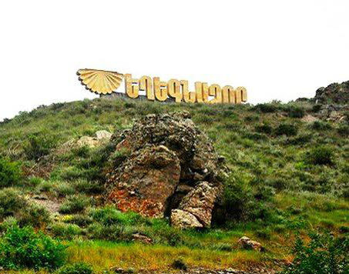

**LOCAL ECONOMIC DEVELOPMENT PLAN**

Community: Yeghegnadzor

Country: Republic of Armenia

15 September 2018

**Preface**

*Local economic development plan of Yeghegnadzor community of Vayots Dzor marz of Armenia is a document reflecting an array of steps for 2018-2021 in terms of targeted community development, which implies economic growth of the community.*

*Given that Yeghegnadzor community has available resources and opportunities that can be used to promote community development and employment, a strategy has been drawn up to attract investments for infrastructure development, to develop agriculture, and to intensify educational-cultural life of the youth.*

***Community Mayor D. Harutyunyan***



For a copy of the Plan please contact:

*Name: Ani Grigoryan*

*Title: Person in charge of LED*

*Address: 1 Shahumyan, c. Yeghegnadzor, Vayots Dzor Marz, Armenia*

*Tel.: +374 44411124*

*E-mail:* [*grigoryan.annie@mail.ru*](mailto:grigoryan.annie@mail.ru)

# Executive Summary

Local economic development plan of Yeghegnadzor community has been elaborated in the framework of Mayors for Economic Growth initiative. During the development of the plan, economic and SWOT analyses of the community were conducted, based on which the community's vision and key objectives were identified. Also, activities for 2018-2021 have been identified, implementation of which will best contribute to the achievement of the set objectives. Yeghegnadzor community is located on Armenia-Iran and Armenia-Artsakh highway. The road to Armenia's main tourist destinations of Tatev and Jermuk crosses through the community, as well as the main wine-making centre of Armenia - Areni community, medieval monastery of Noravank are only 15 km away from the community. Due to the recent projects and historical and cultural monuments Yeghegnadzor community is considered one of the tourism centres of Armenia. Favourable climatic conditions contribute to the development of ecotourism and agritourism. Around 13,000 tourists visit the Community annually.

**Community Vision**

Yeghegnadzor community will become a leading educational, transport, financial and business service centre of Vayots Dzor region and will provide with favourable infrastructure for the development of agribusiness, tourism and processing industry.

**Objectives**

1. Become one of the main destinations for ecotourism in Armenia.

2. The community is a regional educational centre in the spheres of agriculture, wine-making and tourism, providing competitive skilled workers for regional businesses.

3. To have improved infrastructure for private sector development.

In order to achieve the set objectives, the Community will develop its tourism infrastructure (mapping tourist destinations, supporting ecotourism centre development and establishment of new guest houses), support human capital development and product quality improvement, support small and medium-sized businesses, map existing and unused buildings and premises.

The Community is planning to hold a local investment conference aimed at attracting investors by targeting businessmen from the community living abroad.

The main sources of finance necessary for the implementation of the Plan are known. Some part of the costs will be funded from the Community budget, and the other part will be provided through co-financing and grants by international organisations (GIZ), Regional Research Institute of Social and Economic Policy NGO and the European Union.

# Content

1. Executive Summary 3

2. Content 4

3. List of Tables and Figures & Abbreviations 4

4. Introduction to the Plan 5

5. Process of Local Economic Development Plan Development 5

6. Local Economic Analysis 6

7. SWOT Analysis 16

8. Vision and Objectives 16

9. Action Plan 17

10. Financing Scheme 19

11. Monitoring Indicators and Mechanisms 20

# List of Tables and Figures & Abbreviations

Table 1. Presentational Table for Private Sector Companies

Table 2. Assessment of Local Cooperation

Table 3. Growth Sectors (Sub-sectors) & their Challenges

Table 4. Private Sector Needs in Area of Land and Infrastructure

Table 5. Regulatory and Institutional Framework

Table 6A. Skills Situation

Table 6B. How the Local Area is Organised to Balance Required Skills and Employment Opportunities – System Analysis

Table 7. How the Local Area is Perceived by Its Citizens

Table 8. Action Plan

Table 9. Financing Scheme

Table 10. Internal Monitoring Plan of Actions

**Abbreviations**

M4EG – Mayors for Economic Growth

ASUE - Armenian State University of Economics

NGO – Non-governmental organisation

CNCO - Community non-commercial organisations

CSO – Civil society organisation

SME DNC – Small and Medium Entrepreneurship Development National Centre

IT - Information technologies

MA – Municipal administration

LED – Local economic development

EDP - Economic Development Plan

UN - United Nations Organisation

VDM - Vayots Dzor Marz

GIZ - German Corporation for International Cooperation/Deutsche Gesellschaft für Internationale Zusammenarbeit

SWOT – Strengths, weaknesses, opportunities and threats

# Introduction to the Plan

Yeghegnadzor community is situated in the south-eastern part of the Republic of Armenia, 120 km from the capital of Yerevan (1 hour and 45 minutes) and is the regional centre of Vayots Dzor. Yeghegnadzor is the main transportation hub of the region ensuring connection between the settlements of the region and Yerevan. Armenia-Artsakh and Armenia-Iran inter-state road passes through the territory of the Community.

The total area of the lands within the administrative boundaries of the Community is 269.8 hectares, of which over 13 ha are specially protected lands. As of January 1, 2018, Yeghegnadzor with the population of 9,690 is the largest settlement in the region and the administrative, financial and educational centre. 53.6% of the population is men, 46.4% is women. The working-age population is about 4,450. The official unemployment rate is 6%, and the actual unemployment rate is 31%.

Yeghegnadzor community joined Mayors for Economic Growth initiative by the order of Yeghegnadzor Community Mayor No. 03 of January 25, 2018, which encourages the active role of communities in the local economic development process. The main goal of involvement in the initiative is to become an active initiator for the establishment of an environment fostering economic growth of the community, as well as to ensure the harmonious development of economic, social and cultural spheres making the Community one of the best places to live, work, and invest in the region.

The LED plan is based on the Community's five-year development plan, annual work plan, and the outcomes of discussions with representatives of economic partnerships and civil society.

The main sources of finance necessary for the implementation of the Plan are mostly known. Some part of the costs will be funded from the community budget, and the other part will be provided through co-financing and grants by international organisations (GIZ) and foundations (Gagik Tsarukyan charitable foundation).

# Process of Local Economic Development Plan Development

In the framework of Mayors for Economic Growth initiative, Yeghegnadzor community created a working group on January 25, 2018 with the participation of representatives of the municipal administration, private sector and civil society.

The five-year community development program, which was the result of public discussions with the population, served as an important basis for the Plan.

First, stakeholder analysis was done and a Partnership was established with involvement of the MA, private sector, NGOs, community educational institutions and representatives of active community members (composition of the partnership is provided in Annex 3). The person in charge of the Community LED personally met with targeted people informing them about the goals and objectives of the initiative. At the first meeting of the Partnership development steps of the LED Plan were presented in detail and the Plan development team was selected. The team organised meetings with businesses, organisations and agencies to collect necessary information for the purpose of doing structural analysis of Community economy based on questions prepared and clarified in advance. The Community collected information from each organisation with regard to their annual turnover and the number of employees in the past 5 years, as a result of which companies were classified by their size. On the basis of collected information various other analyses were done and presented to the Partnership members. During analysis of each building block area meetings with private and public sector representatives and stakeholders were held to identify existing needs, requirements, situation and future needs.

In March M4EG Coordinator for Armenia and the junior expert visited the Community, who discussed with the Deputy Community Mayor, person in charge of LED and Head of Development Projects and Analysis of the Staff of Vayots Dzor Regional Administration the challenges that the Community faces and clarified further steps.

The person in charge of LED had individual meetings with the credit agents of financial institutions of the Community who presented the lending terms and conditions.

As a result of individual discussions the potential of hotels and guest houses was also identified and the received information was also used for the Plan development.

Individual meetings were held with the director of the Vayots Dzor Regional State College and discussed further steps for the training of wine-makers and specialists in the areas of tourism and hospitality.

# Local Economic Analysis

* 1. Analysis of Local Economic Structure

Yeghegnadzor is one of the oldest settlements in the southern part of Armenia. It is situated on the historic Silk Road and on the touristic southern corridor that is currently under construction.

*Tourism*. Yeghegnadzor community is located on the main highway of Armenia-Iran (Meghri Customs Point) and Armenia-Artsakh. The road leading to the main tourist destinations of Armenia - Tatev and Jermuk passes through the Community, and Areni village is only 15 km away. In 2017, the number of tourists arriving in Armenia was 1.4 million, and the number of domestic tourists - about 1.1 million, of which 15-20% or around 400-500 thousand tourists passed through Yeghegnadzor community.

Gladzor University (13-14th centuries), Spitakavor, St. Cross, St. Sargis Churches, Noravank Monastery Complex, Mozrov Cave, Holy Bridge of Agarakadzor of the 13th century, the Jewish Cemetery, Smbataberd, Tsakhats Kar and many other historical-cultural and valued monuments are in the neighborhood of the Community within a radius of 20 km. Yeghegnadzor Geological Museum, Gladzor Museum, Yeghegnadzor branch of the National Gallery of Armenia are active in the field of cultural heritage.

Despite its position, existing natural advantages and historic-cultural monuments, only 13,000 tourists visited Yeghegnadzor community in 2017, with only 50% staying overnight. This low index is mainly conditioned by poorly developed tourism infrastructure. Hotel facilities in Yeghegnadzor can accommodate about 170 beds (75 rooms). According to the survey, the majority of tourists stay in the Community for 1-3 nights visiting tourist destinations in Yeghegnadzor and neighboring villages within a radius of 20 km. Tourists visiting Yeghegnadzor community are mostly from European countries for historical and cultural monuments, rural tourism, hiking, and ecologically pure products. In 2017 the Community had 6,500 visitors which is by 1,500 more than it was in 2016.

The Community intends to take active steps to attract tourists crossing through the community by making use of tourist destinations of adjacent communities, establishing inter-community relations, offering ecologically pure products to the tourists, supporting tourism development in the region. Attraction of historic-cultural sites and adjacent areas will be enhanced, which will contribute to a longer stay of tourists in the Community.

As of 2017, there were 2 hotels, 21 guest houses, 1 camping facility, 7 restaurants, and 10 fast food facilities. About 6% of the population (600 people) in Yeghegnadzor community is engaged in tourism and service provision sectors. A number of projects are planned for the development of ecotourism in Yeghegnadzor community.

*Agriculture and Food Processing.* The main branches of agriculture in the Community are cattle-breeding, horticulture, field crop cultivation and beekeeping. The community has 1,842.9 ha of agricultural land, of which only 543 hectares are irrigated. There are only 7 companies operating in the Community, one of which is "Golden Goat" LLC, which besides holding a livestock complex is also engaged in goat cheese production. In 2016, 135 tons of cheese was produced, and in 2017 - 300 tons, thus ensuring annual growth of 222%. 90% of the products is exported to Russia. The total capacity of this sector is estimated 750 million drams, where 35 people are employed. Having 351 hectares of pastures the Community has the potential to develop cattle breeding, particularly, goat breeding. Golden Goat LLC now has 500 head of goats and plans to add another 100. The company procures unlimited amount of goat milk, which promotes the residents to engage in goat breeding.

Yeghegnadzor community is famous for its wine-making, as it is evidenced by the medieval wine press discovered in the area of secondary school No 1 of the community in 2018, which can become a new tourist destination.

Since 1990 “Getnatoun” wine factory has been operating, which in 2016 produced 150,000 bottles and in 2017 - 200,000 bottles of grape and pomegranate wines and fruit vodka. The factory employs 25 people and procures from its own orchards and 50 villagers. Compared to 2016, production volume increased by over 20%. The products have mainly been exported to Russia. There are 3 wine factories in Yeghegnadzor community within 10 km radius and there is a need for new ones, as the existing ones are not able to fully procure the harvest of the region. Being adjacent to Areni community, Yeghegnadzor has the opportunity to develop wine-making and establish inter-community links.

The biggest growth was registered in the following sectors: food industry - grapes, vegetables, fruits and berries and dairy products (17%). Yeghegnadzor cannery is distinguished with a relatively high annual turnover. In 2015 Yeghegnadzor cannery procured 1280 tons of fruits and vegetables, and according to the data in 2017 it procured 1690 tons. Compared to 2015, the factory increased its procurement capacity by 24% . The factory has won several gold medals for the best quality in international competitions. The factory has about 40 workplaces.

Potential investors in Yeghegnadzor community are particularly interested in organisation of ecologically pure production. In this regard, there is a great need for conduction of trainings and seminars on ecologically pure farming.

*Other branches of industry.* There is a relay factory in Yeghegnadzor producing mostly motor vehicle relays and employing 46 people. Relays are mainly exported to Russia and are used in aircraft construction.

*Education.* Being the regional centre, vocational and higher education is centered in Yeghegnadzor community. Vayots Dzor Regional State College is the only educational institution in the region that provides primary and secondary vocational education. For the selection of specialisations to be taught there two key criteria are critical: labour market demand and relevance with socio-economic trends in the region. In this regard particularly 3 specialisations should be highlighted: "Tourism", "Woodworking", "Wine-making and juice production". Taking into account expansion of volumes of wine-making and the rich tourism potential of the region, the college has put an emphasis on training competitive staff for these two key areas. The college has acquired a rich material and technical base through collaboration with a number of international organisations that contributes to providing quality education. Particularly, a small wine-making workshop was set up in the college, and the dual system of wine-making training (theory and practical skills) was introduced. Availability of various laboratories and subject-focused classrooms in the college, the fact of being involved in various development and training programs, the staff with competent and high-quality professionals are key to training qualified and skilled workers and meeting the demand of the region's labour market to some extent.

Yeghegnadzor community has a great opportunity to become a centre of secondary vocational education in the region.

Yeghegnadzor branch of the Armenian State University of Economics has been operating since 2008. There are 308 students studying at the university in management, finance, and accounting. The University offers both classroom and distance learning programs of bachelor's and master's degree. As the regional centre, branches of banks, credit organisations, insurance companies and accounting firms are centered in the Community, which enables students to study in their community and find jobs. As per the University data, 90% of graduates finds jobs in the Community. There are 36 people working at the University.

There are 6 organisations of Community subordination - 3 kindergartens, a school of fine arts, children's creative centre and sports school. 92 people are employed in the Community Administration and other organisations under its subordination, which constitutes 4.6% of the total working-age population. The vocational and higher education provided in the Community does not meet the needs of emerging areas of the economy. Agricultural processing specialists are in demand.

IT sector is not developed in the community. 5 micro-enterprises provide legal advice.

*Healthcare.* There is one medical centre and 5 dental clinics in the Community. In 2018, the Armenian government approved the construction of Vayots Dzor Medical Centre in Yeghegnadzor, which will be equipped with modern technologies and trained specialists. The construction of the hospital is underway and is expected to be completed by 2020. Creation of 50 temporary and 90 permanent jobs is envisaged.

*Other Services.* There are 276 micro enterprises in the Community that provide various services to the population.

According to the RA State Registry, in 2017 the number of non-financial enterprises in the community has reached 264, which is by 7% more than it was in 2016. There are 11 financial institutions active in the Community. An increase in the number of businesses has been registered in almost all sectors of the economy.

Community-based organisations have the following distribution:

* 353 micro enterprises,
* 11 small enterprises,

An increase is observed in the construction sector with 8 functioning micro enterprises.

There are also a number of small and medium-sized organisations in the Community: public service provision (8), transportation services (6), real estate agency (1) and so on.

In 2019-2022 major investments will be made in the residential construction for young families.

In order to attract investors in Yeghegnadzor community, we plan to implement a local investment conference targeting businessmen from our city living abroad. We have had similar collaborations in the Community over the previous years and now, in collaboration with community-based businesses, we want to develop investment packages and present them at the conference.

**Table 1. Presentational Table for Private Sector Companies**

|  |  |  |  |  |
| --- | --- | --- | --- | --- |
| Type of economic activities | Micro (1-14 staff) | Small (15-100 staff) | Medium (101-250 staff) | Large (250 and over) |
|  | *Quantity* | *Quantity* | *Quantity* | *Quantity* |
| Industrial manufacturing | **5** | **3** |  |  |
| Agricultural production | **6** | **1** |  |  |
| Retail | **203** |  |  |  |
| Wholesale | **6** |  |  |  |
| Business services | **2** |  |  |  |
| Medical services | **7** | **1** |  |  |
| Legal services | **5** |  |  |  |
| Services to population | **26** |  |  |  |
| Restaurants, cafes, bars, etc. | **11** | **2** |  |  |
| Hotels, hostels, etc. | **21** | **1** |  |  |
| IT services |  |  |  |  |
| Transport | **9** |  |  |  |
| Construction, development | **8** |  |  |  |
| Communication services | **4** | **1** |  |  |
| Creative services | **2** |  |  |  |
| Waste management | **1** |  |  |  |
| Tourism | **3** |  |  |  |
| Cultural heritage | **2** |  |  |  |
| Other | **32** | **2** |  |  |

|  |  |
| --- | --- |
| **STRENGTH** | **WEAKNESS** |
| 1. Agriculture and processing of local raw materials is developed in the Community | 1. Problems related to irrigation network and sales |
| 2. Centre of touristic wine-making cluster | 2. Tourism infrastructures are poorly developed |
| 3. Existence of vocational and higher educational institutions | 3. Outflow of qualified staff |

* 1. Local Cooperation

There are no business associations in the Community due to which there is no cooperation between enterprises. Creation of a Tourist Information Centre, which will act as an organisation with membership of businesses, will include community hotels, guest houses, restaurants, and will promote their progress. As a result of the project implementation, three permanent jobs will be created. The project is planned to be implemented in 2019.

Several times a year the Community Mayor organises meetings with business companies and financial institutions, discusses the necessity of improving community services, potential sources of financing with the purpose of enhancing the Community's role as a tourism, financial and educational centre and becoming more competitive for investments. Since January 2018, an economic development team has been working with community entrepreneurs and non-governmental organisations and implementing a range of projects. There is no partnership between the enterprises as such. General consultations take place as necessary for the purpose of addressing a specific issue of a sector. At the same time the municipal administration is challenged to increase the quality of community services making them more transparent and accessible for all. Any problem related to community development is covered on the official website and Facebook page of the Community ([www.yeghegnadzor.am](http://www.yeghegnadzor.am) and <https://www.facebook.com/yeghegnadzor.vayotsdzor/> ).

**Table 2. Assessment of Local Cooperation**

|  |  |  |  |
| --- | --- | --- | --- |
| ***Title and/or Function (area/theme on which it works)*** | ***Institutions/ Persons involved*** | ***Achievements***  ***(also indicate how it works – e.g. “plans”, implements projects, provides services, is permanent or ad hoc/occasional)*** | ***Assessment: useful or not useful*** |
| Local Economic Development Team | *Representatives of the private sector, CSOs and MA* | Occasional since 2018 | *Useful* |
| *Advisory body adjunct to the Community Mayor* | *Active youth, representatives of culture, education and art, etc.* | *Since 2014, permanent* | *Useful* |
| Tourism | Hotels, guest houses, food service facilities | Plans/occasional | Useful |

|  |  |
| --- | --- |
| **STRENGTH** | **WEAKNESS** |
| 1. Willingness and certain experience of the Community leadership in discussing and resolving economic development issues of the Community with businesses | 1. Lack of formal structures of cooperation (associations, unions) in the private sector |
| 2. Initiation of cooperation in the field of tourism |  |

* 1. Business-friendly, Transparent and Corruption-Free Administration

Before Mayors for Economic Growth initiative, there was no attempt to do such work in Yeghegnadzor community as there was no such department or staff.

The Local Economic Development team was formed in January 2018 and has no experience of working with enterprises and providing information. It usually responds to different inquiries and works with businesses individually. There is no economic development section on the official webpage of the municipality. At the community council, discussions on the official website are underway to add local economic development section on the webpage, to improve communication with businesses, and to provide timely information to all. Apart from the Community Mayor’s meetings there is no other format of cooperation aimed at improvement of business environment towards business needs. Information on business support or donor programs is not posted on the official community website. All the tenders announced by the Municipal Administration are published on the website and all parties concerned can participate in the opening of bids. Satisfactory conditions are created in the Community to be aware of community meetings and discussions, participate in them and come up with suggestions. To that end the official website of the Community and the Facebook page of the Municipal Administration are used where detailed coverage of the activities performed by the Administration and the Council are presented.

**Table 3. Growth Sectors (Sub-sectors) & their Challenges**

|  |  |
| --- | --- |
| ***(Growth) Sector***  ***(sub-sectors)*** | **Main challenges likely requiring business support assistance** |
| *Production* | *A significant part of the Community population is engaged in agriculture; many are engaged in viticulture. Enhancement of effectiveness of irrigation water system and irrigation of non-irrigated areas are among the issues of the sector.* |
| *Tourism* | *Over the past few years, the number of visitors for recreation has increased in the Community, thanks to which the number of guest house-holders has increased. The main problem in this sector is poor infrastructure (roads, entertainment). The Community also has great potential for the development of ecotourism.* |
| Agriculture | *Natural dried fruits without additives as well as a wide range of cheeses and wines is produced in Yeghegnadzor community and exported to Russia. The problem with increasing the volumes of production in the Community is associated with non-affordable loans to support businesses.* |

|  |  |
| --- | --- |
| **STRENGTH** | **WEAKNESS** |
| 1. Transparent competitive framework | 1. There is no section in the municipality website designated for economic development |
| 2. Announcement of all tenders are posted on the website, discussions, hearings and sessions are open, the Municipality comes up with reports | 2. Absence of means for the improvement of business environment |

* 1. Access to Finance

Establishment of branches of commercial banks in the Community gives local businesses an opportunity to expand them and stimulates creation of new businesses. There are branches of 5 banks in the Community, which constitutes 40% of banks operating in Armenia, branches of 8 credit organisations representing 25% of credit organisations in Armenia, and branches of 5 insurance companies constituting 60% of insurance companies operating in Armenia.

Information about available financial resources for business development is collected and provided to businesses. Public awareness campaigns on loans with low interest rates are regularly held in the Community.

Banks operating in the Community provide loans to small and medium-sized enterprises of up to 100 million AMD (interest rate - 14%) with mortgage and 10 million AMD (interest rate - 21%) without mortgage. Commercial banks provide agricultural loans to boost agricultural development at the interest rate of 3-6% per annum (subsidised by the government). There are credit organisations in the Community that provide loans of up to 2 million AMD (at annual interest rate of 24%). SME DNC's regional branch is located in Vayk, and the business community learns about their projects from social networks and banks, and sometimes the Municipality posts announcements on its official webpage.

In order to ensure better access of financial products for businesses, the local economic development team plans collaboration of the Municipality with the financial sector. In addition to collaborating with business support structures, it is essential to build the capacities of existing and start-up businesses, which will help make their projects more realistic and increase chances of leveraging finances.

|  |  |  |  |  |  |
| --- | --- | --- | --- | --- | --- |
| **Institution/donor (including banks and other credit organisations)** | **Potential customers / beneficiaries** | | **Preferred economic sectors/activity** | **Minimum and maximum amount required** | **Requirements**  **(mortgage, etc.)** |
| Commercial banks | SME  Community residents | | Trade and service provision, construction | Up to 100 mln.AMD  Up to 10 mln. AMD | Mortgage,  Guarantor |
| Credit organisations | SME  Community residents | | Trade and service provision | Up to 2 mln. AMD | Guarantor |
| Community | Non-governmental organisations | | Tourism | Up to 1 mln. AMD |  |
| **STRENGTH** | | | **WEAKNESS** | | | |
| A large number of financial institutions offer almost the entire spectrum of financial services available in the market | | | High interest rates | | | |
| Provision of information and advisory services | | | Lending restrictions for start-up businesses | | | |

* 1. Land and Infrastructure

Positive trend of business development also results in increase of demand for workspace, land and infrastructures. In Soviet years Yeghegnadzor used to be a major industrial town with a number of factories and although those factories are private properties now, the owners rent out the premises to other businesses.

The main demand comes from micro enterprises and individual salespersons who want workspace with common facilities.

The Municipality exerts huge efforts in identification of all community lands and buildings and their physical conditions. The Community has no unused office premises. The Municipality mainly cooperates with investors providing community-owned land for the establishment of businesses.

**Table 4. Private Sector Needs in Area of Land and Infrastructure**

|  |  |  |
| --- | --- | --- |
| **Expressed private sector needs by type of infrastructure** | **Existing Provision in this segment** | **Indicative future requirements (within 6 years)** |
| Micro-company or sole trader workspace (workshops) – (with/without) shared common facilities | Non-residential premises on the first floors of multi-apartment buildings or pavilions allocated and built in various parts of the Community in compliance with urban development norms, and premises of former factories against corresponding rent are used as workspace | Each business improves their workspace by their own means |
| Office space – (with/without) shared common facilities | None |  |
| Business incubator (< 10 start-up /micro businesses, > 10 start-up /micro businesses) | None |  |
| Business/ Industrial park (fleet) | None |  |

|  |  |
| --- | --- |
| **STRENGTH** | **WEAKNESS** |
| 1. Finding premises for rent for business is easy | 1. No business incubators or science/technology parks |
|  | 2. No community-owned buildings |

* 1. Regulatory and Institutional Framework

Residents’ service provision office with "one-stop-shop" principle has opened in the Municipality as a result of which the services provided by the Municipality have improved. Despite some progress, some unjustified rules, regulations, and other administrative barriers remain. The biggest problem is all the processes through which one needs to go to obtain a construction permit. There is no cooperation between the State Committee of Real Estate Cadastre, the notary office and the Municipality and they all demand the same information from the residents.

Cooperation between the Municipality, State Committee of Real Estate Cadastre by the RA Government and the notary offices is also quite flexible.

Local duties and fees are set by the Community Council on the basis of the rates set forth by the RA Law “On local duties and fees”. In Yeghegnadzor community minimum or middle rates provided for by law have mostly been set; the maximum rate is almost not applied.

**Table 5. Regulatory and Institutional Framework**

|  |  |  |  |
| --- | --- | --- | --- |
| **Agreed Regulatory Challenges** | **High/ Low Negative Impact** | **Main public agency involved** | **Scope for local mitigation/improvement** (details) |
| Residents’ service provision office | Low | MA | Quality improvement of provided services |
| Tax policy | Low | State Revenue Committee | Support to start-up businesses |
| Cooperation between Municipality-Cadastre-Notary office | Low | MA | People will not have to wait and the data and time will be checked by phone |
| Promotion of new businesses | Low | MA | With the purpose of boosting business development, reduction of levied local taxes, duties and fees is applied |

|  |  |
| --- | --- |
| **STRENGTH** | **WEAKNESS** |
| 1. Residents’ service provision office | 1. Residents are not used to submitting their inquiries and receiving answers online and they submit requests in paper form |
| 2. Equal conditions for accessibility | 2. Non-flexible system of local taxes and duties |

* 1. Skills and Human Capital, Inclusiveness

Pursuant to the Armenian legislation, jurisdiction of the Municipality in the field of education is restricted to preschool education. Since 1971 Vayots Dzor Regional State College has been functioning in the Community providing primary and secondary vocational education. The college offers also short-term training programs.

Since 2008 the branch of the Armenian State University of Economics has been functioning where students get BA and MA degrees in economics in classroom and distance learning courses.

Development of tourism in the Community has given rise to a high demand for waiters/waitresses, tour guides and service providers with the knowledge of foreign languages. Labour force development in the sectors of construction, trade and hospitality is required. Due to seasonal labour migration, there is a lack of qualified professionals. As a result, jobs are not staffed with professionals. In terms of quantitative, structural and qualitative qualities vocational schools still fail to adequately respond to the demands of local job market. There is discrepancy between workforce supply and demand. The Employment Centre conducts some training but it does not cooperate with the private sector. There is lack of coordination between municipal administration, business, educational and training institutions.

**Table 6A. Skills Situation**

|  |  |  |  |
| --- | --- | --- | --- |
| **Strengths in Current Ways of Working** | **Degree of Importance (1-5)** | **Weaknesses in Current Ways of Working** | **Degree of Importance (1-5)** |
| Availability of Territorial Employment Centre | 5 | No vacancy  announcements | 5 |
| Requirements presented by employers | 5 | Non-transparency of presenting the demand | 5 |
| Vocational trainings and extension activities | 5 | Irregular organisation | 5 |
| Availability of Territorial Employment Centre | 5 | No vacancy announcements | 5 |
| **Possible Improved Ways of Working** | | | |
| Cooperation between the Employment Centre and employers. | | | |
| Coordination between municipal administration, business, educational and training institutions. | | | |

|  |  |
| --- | --- |
| **STRENGTH** | **WEAKNESS** |
| 1. Geographic location and the fact of being the regional centre | 1. Scarce financial resources |
| 2. Higher and vocational educational institutions | 2. Lack of cooperation between educational institutions and employees |

* 1. External Positioning and Marketing

The level of development of the region is disproportionate. Yeghegnadzor is distinguished by the capacity of financial, educational, manufacturing and agricultural enterprises of the region, which is associated with the opening of branches of tourism and financial institutions and the establishment of the branch of the University of Economics. Thanks to new conditions, small businesses are developing in the Community - wine-making, cooperage, stone processing, concrete objects, bakery, pastry production, furniture production, etc. About 300 people work in the mentioned enterprises.

In recent years the Community has significantly improved its infrastructures, increased and took care of green areas, built an amphitheater, playgrounds, and expanded the community lighting network.

The Community does not have a developed brand, slogan and community marketing strategy, besides, no marketing campaigns for community promotion are carried out.

According to visitors, Yeghegnadzor is an attractive place for residence, work, visit and investments. In recent years the Municipality has paid great attention to the improvement of the appearance of the town. On the initiative of the Municipality metal pavilions irregularly placed in the community are being dismantled and removed from the territory of the community.

In recent years businessmen have also started to improve their workspaces by renovating and giving them a more modern appearance, which has positively affected the general appearance of the town.

Inflow of tourists from abroad is triggered by Areni Wine Festival and other festivals held in Jermuk.

The Municipality is trying to be presented in various festivals and events with local products, such as a variety of Yeghegnadzor wines, cheeses, dried fruits, preserves and jams.

**Table 7. How the Local Area is Perceived by Its Citizens**

|  |  |  |  |
| --- | --- | --- | --- |
| **Likes/Perceived Strengths in the Image we Project Externally** | **Degree of Importance (1-5)** | **Dislikes/Perceived Weaknesses in the Image we Project Externally** | **Degree of Importance (1-5)** |
| New modern parks | 5 | Distance from the capital | 4 |
| Improved infrastructures | 4 | Difficulties with consumption of local production | 5 |
| Big potential for tourism development | 3 | Absence of tourism information centre | 5 |
| Transparent and adequate governance | 4 | Community-private sector partnership | 4 |
| **Possible actions that could easily be implemented** | | | **Led by** |
| Adding a new section in the Community webpage [www.yeghegnadzor.am](http://www.yeghegnadzor.am) and promotion of attractiveness of Yeghegnadzor community | | | MA |
| Participation in tourism-related events and exhibitions | | | MA |
| Develop a community guide and do mapping | | | MA |

|  |  |
| --- | --- |
| **STRENGTH** | **WEAKNESS** |
| 1. Cultural-historical monuments | 1. Distance from the capital |
| 2. Geographic location | 2․ No signboards, guides and maps of the Community |

## 

# SWOT Analysis

|  |  |
| --- | --- |
| **Strengths** | **Weaknesses** |
| * Geographic location - inter-state highway linking Syunik marz, Nagorno-Karabakh Republic and the Islamic Republic of Iran with Yerevan passes through Yeghegnadzor * Rich natural and historical-cultural resources - conservation areas, caves and well-known medieval monuments * Availability of full value chains of wine, cheese (especially goat cheese), dried fruits, canned food production * Armenia's leading centre of wine-making and tourism cluster * Centre of primary and secondary vocational and higher education in the region | * Lack of qualified labour force * Insufficient development of tourism and business infrastructures * Moral and physical depreciation of community-based structures and property * No tourism information centre and tourism products/packages * No travel agencies * No branding and city marketing events |
| **Opportunities** | **Threats** |
| * Developing tourism in Armenia, which allows to attract new tourists to Yeghegnadzor * High rates of wine-making and tourism development in the region * Festivals organised in the marz - Areni Wine Festival, Khachik Gata Festival, Jermuk Snowman Festival * Construction of the North-South highway, which will reduce the duration of travel from Yerevan and will improve the quality | * Possibility of Azerbaijani aggression from the direction of Nakhijevan * Migration of young people * Low birth rate * Major mining projects that create environmental risks |

# Vision and Objectives

**Vision of Community Development**

Yeghegnadzor community will become a leading educational, transport, financial and business service centre of Vayots Dzor region and will provide with favourable infrastructure for the development of agribusiness, tourism and processing industry.

**Key objectives**

1. Become one of the main destinations for ecotourism in Armenia.

2. The community is a regional educational centre in the spheres of agriculture, wine-making and tourism, providing competitive skilled workers for regional businesses.

3. To have improved infrastructure for private sector development.

# Action Plan

|  |  |  |  |  |  |  |  |
| --- | --- | --- | --- | --- | --- | --- | --- |
| ***Building blocks*** | ***Key Objectives*** | ***Actions /***  ***Projects ideas*** | ***Duration (start/finish)*** | ***Partners involved*** | ***Estimated costs***  ***In local currency (equivalent in Euro)*** | ***Monitoring indicators/ Output indicators and targets*** | ***Outcomes /***  ***Result indicators and targets*** |
| 1. Land and Infrastructure 2. Access to Finance 3. Skills and Human Capital, Inclusiveness 4. External Positioning and Marketing | 1. 1. Become one of the main destinations for ecotourism in Armenia. | 1.1. Mapping of tourism assets of Yeghegnadzor, installation of signboards | 2019-2020 | Regional Research Institute of Social and Economic Policy NGO, MA | 3,000,000 AMD,  5,172 € | * Number of installed signboards and guides, * Map of tourist destinations of Yeghegnadzor community | * Annual increase of the number of tourists staying overnight by at least 5% * Creation of 16 new jobs |
| 1.2 Establishment of a Regional Centre of Ecotourism Development and Marketing | 2018-2020 | European Union, RA Government, MA, Regional Administration of Vayots Dzor, Regional Centre of Tourism NGO | 8,700,000 AMD,  15,000 € | * Creation of 2 permanent jobs * Mapping of guest houses, hotels, eating facilities in the region and information support to tourists |
| 1.3. Support establishment of guest houses for ecotourism development | 2019-2020 | European Union, RA Government, MA, Regional Administration of Vayots Dzor, Regional Centre of Tourism NGO | 10,000,000 AMD,  17,240 € | * Creation of 7 new jobs * Creation of 14 new jobs |
| 1. Land and Infrastructure 2. Skills and Human Capital, Inclusiveness 3. External Positioning and Marketing | 2. 2. The community is a regional educational centre in the spheres of agriculture, wine-making and tourism, providing competitive skilled workers for regional businesses. | 2.1. Training courses of entrepreneurial skills development | 2019-2020 | MA, Vayots Dzor Regional State College, Save the Children, Regional Research Institute of Social and Economic Policy NGO | 800,000 AMD, 1,379 € | * Training on entrepreneurial skills development consisting of 3 seminars * 15 training participants | * 10 newly hired residents * Increase of wine-making and agricultural production by 10% |
| 2.2 Training of start-up wine-makers | 2019-2020 | MA, Vayots Dzor Regional State College, “Anushavan Abrahamyan” benevolent educational foundation, Young Wine-makers NGO, GIZ | 1,330,000 AMD, 2,290 € | * 15 trained wine-makers * 5 trainings conducted |
| 2.3 Organisation of trainings on agriculture which will contribute to the residents’ engagement in this sector | 2020 | MA, Vayots Dzor Regional Administration, SME DNC | 900,000 AMD, 1,550 € | * 3 trainings organised * 20 training participants |
| 1. Land and Infrastructure 2. Skills and Human Capital, Inclusiveness 3. External Positioning and Marketing | 3. To have improved infrastructure for private sector development. | 3.1 Organise a local investment conference aimed at attracting investors by targeting businessmen from the community living abroad | 2019-2020 | MA, Vayots Dzor Regional Administration, private sector | 450,000 AMD  775 € | * 1 investment conference held * At least 15 conference participants * At least 4 signed memoranda on potential investment projects | * Decrease of unemployment rate by 5% * At least 3 investment projects implemented * Residents’ improved perception of the Community as a favourable location for living and work * Raising awareness of potential investors * New enterprises created |
|  | 3.2 Stocktaking and mapping of available used and unused buildings and premises in Yeghegnadzor | 2019 | MA | 531,000 AMD, 900€ | * E-catalog of enterprises, their production and existing premises |
| 3.3 Construction of irrigation pipeline | 2020 | MA, RA Government | 5,000,000 AMD, 8,770 € | * 2-km long pipeline built * Expansion of vineyards by 10 ha |

# Financing Scheme

***Table 9. Financing Scheme***

|  |  |  |  |  |  |  |  |
| --- | --- | --- | --- | --- | --- | --- | --- |
| ***Actions*** | ***Estimated costs*** | ***Source of financing*** | | | | ***Funding gaps*** | ***Remarks*** |
| ***Local budget*** | ***Upper level budgets*** | ***Business*** | ***Donors*** |
| 1.1. Mapping of tourism assets of Yeghegnadzor, installation of signboards | 3,000,000 AMD,  5,172 € |  |  |  | 100% |  | Regional Research Institute of Social and Economic Policy NGO, MA |
| 1.2 Establishment of a Regional Centre of Ecotourism Development and Marketing | 8,700,000 AMD, 15,000€ |  |  |  | 100% |  | European Union, RA Government, MA, Regional Administration of Vayots Dzor, Regional Centre of Tourism NGO |
| 1.3. Support establishment of guest houses for ecotourism development | 10,000,000 AMD,  17,240 € | 20% |  |  | 80% |  | European Union, RA Government, MA, Regional Administration of Vayots Dzor, Regional Centre of Tourism NGO |
| 2.1. Training courses of entrepreneurial skills development | 800,000 AMD, 1,379 € |  |  |  | 100% |  | MA, Vayots Dzor Regional State College, Save the Children, Regional Research Institute of Social and Economic Policy NGO |
| 2.2 Training of start-up wine-makers | 1,330,000 AMD, 2,290 € |  |  |  | 100% |  | MA, Young Wine-makers NGO, GIZ |
| 2.3 Organisation of trainings on agriculture which will contribute to the residents’ engagement in this sector | 900,000 AMD, 1,550 € |  |  |  | 100% |  | MA, Vayots Dzor Regional Administration, SME DNC |
| 3.1 Local investment conference aimed at attracting investors by targeting businessmen from the community living abroad | 450,000 AMD,  775 € | 50 % | 50 % |  |  |  | MA, Vayots Dzor Regional Administration, private sector |
| 3.2 Stocktaking and mapping of available used and unused buildings and premises in Yeghegnadzor | 531,000 AMD, 900 € | 100 % |  |  |  |  | MA |
| 3.3 Construction of irrigation pipeline | 5,000,000 AMD, 8,770 € | 60 % | 40 % |  |  |  | MA, RA Government |
| **Total** | **31,711,000 AMD/ 53,076€** |  |  |  |  |  |  |

# Monitoring Indicators and Mechanisms

***Table 10. Internal Monitoring Plan of Actions***

|  |  |  |  |  |  |
| --- | --- | --- | --- | --- | --- |
| Actions / Projects ideas | Duration (start/finish) | Expected results  1st-6th months | Expected results  6-12th months | Expected results  12-18th months | Expected results  18-24th months |
| * 1. Mapping of tourism assets of Yeghegnadzor, installation of signboards | 2019-2020 | * Community mapping activities on hotels, guest houses, historical and cultural sites, and services | * Installation of signboards and guiding information | * Installation of electronic signboards | * Maps and signboards installed in the Community |
| 1.2 Establishment of a Regional Centre of Ecotourism Development and Marketing | 2018-2020 | * Design-estimate documents prepared | * Company to carry out renovation selected through a competition * Renovation underway | * Stocktaking of resources available in the Community and establishment of collaborations | * Existence of a Regional Centre of Ecotourism Development and Marketing |
| 1.3. Support establishment of guest houses for ecotourism development | 2019-2020 | * Organisation of trainings * Submission of business plans * Funding of 7 most successful business plans | * Design-estimate documents prepared | * 7 new guest houses established * 14 new jobs created | * Improvement of related infrastructures |
| 2.1. Training courses of entrepreneurial skills development | 2019-2020 |  | * Preparations for the organisation of trainings | * Preliminary list of participants prepared * Invitations sent to participants | * Training on entrepreneurial skills development consisting of 3 seminars * 15 training participants |
| 2.2 Training of start-up wine-makers | 2019-2020 | * Preparations for the organisation of trainings | * Preliminary list of participants prepared * Invitations sent to participants | * 5 trainings conducted for start-up wine-makers | * 15 trained wine-makers |
| 2.3 Organisation of trainings on agriculture which will contribute to the residents’ engagement in this sector | 2020 |  | * Preparations for the organisation of trainings | * 3 trainings organised | * 20 training participants |
| 3.1 Local investment conference aimed at attracting investors by targeting businessmen from the community living abroad | 2019-2020 | * Strategy of attracting investors developed | * Businessmen from our community living abroad are selected and invited | * At least one investment conference with at least 15 participants is held with 4 signed investment memoranda | * 2 investment projects are underway |
| 3.2 Stocktaking and mapping of available used and unused buildings and premises in Yeghegnadzor | 2019 | * Key information about land types, areas, place and activity of enterprises is collected | * The entire information is added on the official website of Yeghegnadzor Community * Increase of satisfaction of those making use of the Municipality services |  |  |
| 3.3 Construction of irrigation pipeline | 2020 |  |  | * Design-estimate documents prepared | * 3-km long new irrigation pipeline built |

# Annexes

***Հավելված 1. ՏՏԶ պլանով նախատեսված գործողությունների նկարագիր***

|  |  |
| --- | --- |
| ***Գործողությունների նկարագրություն*** | |
| ***Անվանում*** | 1․1 Եղեգնաձոր համայնքի զբոսաշրջային ակտիվների քարտեզագրում, ցուցանակների տեղադրում։ |
| ***Առաջատար գործընկեր*** | Սոցիալ-տնտեսական քաղաքականության տարածաշրջանային հետազոտությունների ինստիտուտ ՀԿ |
| ***Մասնակից գործընկերներ*** | ՏԻՄ |
| ***Մեկնարկի ամսաթիվ*** | 2018 թվական |
| ***Տևողություն*** | 36 ամիս |
| ***Ընդհանուր գնահատված ծախս*** | 5172 € |
| ***Կապիտալ ծախսեր (եթե կան)*** | 3 500€ |
| ***Այլ ծախսեր (եթե կան)*** | 1672 € |
| ***Ֆինանսավորման աղբյուրներ (եթե հայտնի են)*** | Սոցիալ-տնտեսական քաղաքականության տարածաշրջանային հետազոտությունների ինստիտուտ ՀԿ |
| ***Արդյունք (անհրաժեշտության դեպքում՝ ցուցիչներ)*** | * Տեղադրված ցուցանակների և ուղեցույցերի քանակ, * Եղեգնաձոր համայնքի զբոսաշրջային վայրերի քարտեզ |
| ***Վերջնարդյունք՝ ցուցանիշներով*** | Գիշերակացով այցելող զբոսաշրջիկների ավելացում 5%-ով։ |
| ***Պլանավորված նպատակներ, որոնց իրագործմանը նպաստելու է գործողության իրականացումը*** | Եղեգնաձոր համայնքում զբոսաշրջիկների համար ստեղծել բարենպաստ միջավայր հյուրանոցներ, հյուրատներ և ռեստորաններ գտնելու համար։ |
| ***Գործողությանն առնչվող հիմնասյուները*** | Հող և ենթակառուցվածքներ， ֆինանսական միջոցների հասանելիություն， հմտություններ և մարդկային կապիտալ， ներառականություն， արտաքին դիրքավորում և մարքեթինգ |

|  |  |
| --- | --- |
| ***Գործողությունների նկարագրություն*** | |
| ***Անվանում*** | **1․2** Էկոտուրիզմի զարգացման և մարկետինգի մարզային կենտրոնի ստեղծում |
| ***Առաջատար գործընկեր*** | Եվրոմիություն, ՀՀ կառավարություն,  <<Տուրիզմի տարածաշրջանային կենտրոն>> ՀԿ |
| ***Մասնակից գործընկերներ*** | ՏԻՄ |
| ***Մեկնարկի ամսաթիվ*** | 2019 թվական |
| ***Տևողություն*** | 36 ամիս |
| ***Ընդհանուր գնահատված ծախս*** | 15 000 € |
| 1. ***Կապիտալ ծախսեր (եթե կան)*** | 15 000 € |
| 1. ***Այլ ծախսեր (եթե կան)*** | - |
| ***Ֆինանսավորման աղբյուրներ (եթե հայտնի են)*** | Հայտնի չէ |
| ***Արդյունք (անհրաժեշտության դեպքում՝ ցուցիչներ)*** | * 2 հիմնական աշխատատեղի ստեղծում * մարզի տարածքում գործող հյուրատների, հյուրանոցների, սննդի կետերի քարտեզագրում և տեղեկատվական աջակցություն զբոսաշրջիկներին |
| ***Վերջնարդյունք՝ ցուցանիշներով*** | Գիշերակացով այցելող զբոսաշրջիկների ավելացում 5%-ով։ |
| ***Պլանավորված նպատակներ, որոնց իրագործմանը նպաստելու է գործողության իրականացումը*** | Եղեգնաձոր համայնքում զարգացնել զբոսաշրջությունը |
| ***Գործողությանն առնչվող հիմնասյուները*** | Հող և ենթակառուցվածքներ， հմտություններ և մարդկային կապիտալ， ներառականություն， արտաքին դիրքավորում և մարքեթինգա |

|  |  |
| --- | --- |
| ***Գործողությունների նկարագրություն*** | |
| ***Անվանում*** | **1․3** Աջակցել էկոտուրիզմի զարգացման համար հյուրատների ստեղծմանը |
| ***Առաջատար գործընկեր*** | Եվրոմիություն, ՀՀ կառավարություն,  <<Տուրիզմի տարածաշրջանային կենտրոն>> ՀԿ |
| ***Մասնակից գործընկերներ*** | ՏԻՄ |
| ***Մեկնարկի ամսաթիվ*** | 2019 թվական |
| ***Տևողություն*** | 36 ամիս |
| ***Ընդհանուր գնահատված ծախս*** | 17 240 € |
| 1. ***Կապիտալ ծախսեր (եթե կան)*** | 15 000 € |
| 1. ***Այլ ծախսեր (եթե կան)*** | 2 240€ |
| ***Ֆինանսավորման աղբյուրներ (եթե հայտնի են)*** | Հայտնի չէ |
| ***Արդյունք (անհրաժեշտության դեպքում՝ ցուցիչներ)*** | * 7 նոր աշխատատեղի ստեղծում * 14 նոր աշխատատեղի ստեղծում |
| ***Վերջնարդյունք՝ ցուցանիշներով*** | * Գիշերակացով այցելող զբոսաշրջիկների ավելացում տարեկան առնվազն 5%-ով։ * Համայնքում էկոտուրիզմի զարգացման խթանում |
| ***Պլանավորված նպատակներ, որոնց իրագործմանը նպաստելու է գործողության իրականացումը*** | Համայնքում զարգացնել զբոսաշրջությունը, աջակցել նոր հյուրատների և աշխատատեղերի ստեղծմանը։ Համայնքում աջակցել ներդումների և բիզնեսի զարգացմանը։ Ստեղծել բիզնես միջավայր։ |
| ***Գործողությանն առնչվող հիմնասյուները*** | Հող և ենթակառուցվածքներ， հմտություններ և մարդկային կապիտալ， ներառականություն， արտաքին դիրքավորում և մարքեթինգ |

|  |  |
| --- | --- |
| ***Անվանում*** | **2․1** Ձեռնարկատիրական հմտությունների զարգացման դասընթացներ |
| ***Առաջատար գործընկեր*** | Սեյվ դը Չիլդրեն |
| ***Մասնակից գործընկերներ*** | ՏԻՄ，Վայոց ձորի պետական տարածաշրջանային քոլեջ , |
| ***Մեկնարկի ամսաթիվ*** | 2019-2021թթ |
| ***Տևողություն*** | 36 ամիս |
| ***Ընդհանուր գնահատված ծախս*** | 1379 € |
| 1. ***Կապիտալ ծախսեր (եթե կան)*** | չկան |
| 1. ***Այլ ծախսեր (եթե կան)*** | 1379 € |
| ***Ֆինանսավորման աղբյուրներ (եթե հայտնի են)*** | Չկան |
| ***Արդյունք (անհրաժեշտության դեպքում՝ ցուցիչներ)*** | * «Ձեռնարկատիրական հմտությունների զարգացման » թեմայով 3 սեմինարից բաղկացած դասընթաց * դասընթացի 15 մասնակից |
| ***Վերջնարդյունք՝ ցուցանիշներով*** | Ձեռնարկատիրությամբ զբաղվողների թվի ավելացում 5 %-ով |
| ***Պլանավորված նպատակներ, որոնց իրագործմանը նպաստելու է գործողության իրականացումը*** | Նպաստել համայնքում ձեռնակատիրության զարգացմանը |
| ***Գործողությանն առնչվող հիմնասյուները*** | Հող և ենթակառուցվածքներ， հմտություններ և մարդկային կապիտալ， ներառականություն， արտաքին դիրքավորում և մարքեթինգ |

|  |  |
| --- | --- |
| ***Անվանում*** | **2․2** Սկսնակ գինեգործների վերապատրաստում |
| ***Առաջատար գործընկեր*** | Անուշավան Աբրահամյանի բարեգործական կրթական հիմնադրամ, Երիտասարդ գինեգործներ ՀԿ, GIZ |
| ***Մասնակից գործընկերներ*** | ՏԻՄ |
| ***Մեկնարկի ամսաթիվ*** | 2019-2021թթ |
| ***Տևողություն*** | 36 ամիս |
| ***Ընդհանուր գնահատված ծախս*** | 2290 € |
| 1. ***Կապիտալ ծախսեր (եթե կան)*** | 2290 € |
| 1. ***Այլ ծախսեր (եթե կան)*** |  |
| ***Ֆինանսավորման աղբյուրներ (եթե հայտնի են)*** |  |
| ***Արդյունք (անհրաժեշտության դեպքում՝ ցուցիչներ)*** | * Գինեգործության և խաղողագործության մասնագիտության զարգացում， |
| ***Վերջնարդյունք՝ ցուցանիշներով*** | * 15 վերապատրաստված գինեգործ * 5 իրականացված դասընթաց |
| ***Պլանավորված նպատակներ, որոնց իրագործմանը նպաստելու է գործողության իրականացումը*** | Համայնքում զարգացնել գինեգործությունը |
| ***Գործողությանն առնչվող հիմնասյուները*** | Հող և ենթակառուցվածքներ， հմտություններ և մարդկային կապիտալ， ներառականություն， արտաքին դիրքավորում և մարքեթինգ |

|  |  |
| --- | --- |
| ***Անվանում*** | **2․3** Գյուղատնտեսության թեմայով դասընթացների կազմակերպում, որը կնպաստի բնակիչների ակտիվացմանը գյուղատնտեսության ոլորտում |
| ***Առաջատար գործընկեր*** | ՓՄՁ ԶԱԿ |
| ***Մասնակից գործընկերներ*** | ՏԻՄ , ՎՁ մարզպետարան |
| ***Մեկնարկի ամսաթիվ*** | 2020թ |
| ***Տևողություն*** | 12ամիս |
| ***Ընդհանուր գնահատված ծախս*** | 1 550   € |
| 1. ***Կապիտալ ծախսեր (եթե կան)*** | 1 550   € |
| 1. ***Այլ ծախսեր (եթե կան)*** |  |
| ***Ֆինանսավորման աղբյուրներ (եթե հայտնի են)*** |  |
| ***Արդյունք (անհրաժեշտության դեպքում՝ ցուցիչներ)*** | * 3 կազմակերպված դասընթաց * 20 դասընթացի մասնակից |
| ***Վերջնարդյունք՝ ցուցանիշներով*** | 3 կմ երկարությամբ ոռոգման ջրագծի առկայություն |
| ***Պլանավորված նպատակներ, որոնց իրագործմանը նպաստելու է գործողության իրականացումը*** | Համայնքում խթանել գյուղատնտեսության զարգացումը, որը կնպաստի աշխատատեղերի ստեղծմանը |
| ***Գործողությանն առնչվող հիմնասյուները*** | Հող և ենթակառուցվածքներ， հմտություններ և մարդկային կապիտալ， ներառականություն， արտաքին դիրքավորում և մարքեթինգ |

|  |  |
| --- | --- |
| ***Անվանում*** | **3․1** Ներդրողներ ներգրավելու նպատակով տեղական ներդրումային համաժողով՝ թիրախավորելով արտերկրում բնակվող գործարար համաքաղաքացիներին |
| ***Առաջատար գործընկեր*** | Եղեգնաձորի համայնքապետարան |
| ***Մասնակից գործընկերներ*** | ՀՊՏՀ Եղեգնաձորի մասնաճյուղ |
| ***Մեկնարկի ամսաթիվ*** | 2019-2021թթ |
| ***Տևողություն*** | 12ամիս |
| ***Ընդհանուր գնահատված ծախս*** | 775 € |
| 1. ***Կապիտալ ծախսեր (եթե կան)*** | 775 € |
| 1. ***Այլ ծախսեր (եթե կան)*** |  |
| ***Ֆինանսավորման աղբյուրներ (եթե հայտնի են)*** |  |
| ***Արդյունք (անհրաժեշտության դեպքում՝ ցուցիչներ)*** | * համաժողովին առնվազն 15 մասնակից * Առնվազն 4 կնքված հուշագիր հնարավոր ներդրումային ծրագրերի վարաբերյալ |
| ***Վերջնարդյունք՝ ցուցանիշներով*** | իրականացված 3 ներդրումային ծրագիր |
| ***Պլանավորված նպատակներ, որոնց իրագործմանը նպաստելու է գործողության իրականացումը*** | Նպաստել գործարար միջավայրի զարգացմանը |
| ***Գործողությանն առնչվող հիմնասյուները*** | Հող և ենթակառուցվածքներ， հմտություններ և մարդկային կապիտալ， ներառականություն， արտաքին դիրքավորում և մարքեթինգ |

|  |  |
| --- | --- |
| ***Անվանում*** | **3․2** Իրականացնել Եղեգնաձորում առկա գործող և չոգտագործվող շենք-շինությունների գույքագրում և քարտեզագրում |
| ***Առաջատար գործընկեր*** | ՏԻՄ |
| ***Մասնակից գործընկերներ*** |  |
| ***Մեկնարկի ամսաթիվ*** | 2019թ |
| ***Տևողություն*** | 24 ամիս |
| ***Ընդհանուր գնահատված ծախս*** | 900 € |
| 1. ***Կապիտալ ծախսեր (եթե կան)*** |  |
| 1. ***Այլ ծախսեր (եթե կան)*** | 900 € |
| ***Ֆինանսավորման աղբյուրներ (եթե հայտնի են)*** |  |
| ***Արդյունք (անհրաժեշտության դեպքում՝ ցուցիչներ)*** | ձեռնարկությունների , նրանց արտադրանքների և առկա շենք-շինությունների էլեկտրոնային շտեմարան |
| ***Վերջնարդյունք՝ ցուցանիշներով*** | * Պոտենցիալ ներդրողների մոտ տեղեկատվության բարձրացում * Ստեղծված նոր ձեռնարկություններ * Կառուցված առևտրի և սպասարկման, հանգստի և ժամանցի օբյեկտներ |
| ***Պլանավորված նպատակներ, որոնց իրագործմանը նպաստելու է գործողության իրականացումը*** | Համայնքում նոր ներդրումների խթանում |
| ***Գործողությանն առնչվող հիմնասյուները*** | Հող և ենթակառուցվածքներ， հմտություններ և մարդկային կապիտալ， ներառականություն， արտաքին դիրքավորում և մարքեթինգ |

|  |  |
| --- | --- |
| ***Անվանում*** | **3․3** Ոռոգման ջրագծի կառուցում |
| ***Առաջատար գործընկեր*** | ՏԻՄ |
| ***Մասնակից գործընկերներ*** | ՀՀ կառավարություն |
| ***Մեկնարկի ամսաթիվ*** | 2021թ |
| ***Տևողություն*** | 12 ամիս |
| ***Ընդհանուր գնահատված ծախս*** | 8 770 € |
| 1. ***Կապիտալ ծախսեր (եթե կան)*** | 8 770 € |
| 1. ***Այլ ծախսեր (եթե կան)*** | Չկան |
| ***Ֆինանսավորման աղբյուրներ (եթե հայտնի են)*** | Չկան |
| ***Արդյունք (անհրաժեշտության դեպքում՝ ցուցիչներ)*** | * 3 կմ ոռոգման ոռոգման ցանցի կառուցում * Գյուղատնտեսությամբ զբաղվող անձանց թվի ավելացում 5 %-ով |
| ***Վերջնարդյունք՝ ցուցանիշներով*** | 3 կմ ոռոգման ցանցի առկայություն |
| ***Պլանավորված նպատակներ, որոնց իրագործմանը նպաստելու է գործողության իրականացումը*** | * չոռոգվող և չօգտագործվող հողերի նպատակային օգտագործում, * Նոր հիմնված այգիներ ; |
| ***Գործողությանն առնչվող հիմնասյուները*** | Հող և ենթակառուցվածքներ， հմտություններ և մարդկային կապիտալ， ներառականություն， արտաքին դիրքավորում և մարքեթինգ |

**Հավելված 2․ ՏՏԶ պլանի մշակման նպատակով շահագրգիռ կառույցների հետ քննարկումների ցանկ**

|  |  |  |  |  |
| --- | --- | --- | --- | --- |
| *N* | *Մասնակիցները* | *Հանդիպումների բովանդակությունը* | *Օրը* | *Վայրը* |
| *1․* | *Եղեգնաձոր համայնքի ղեկավարի տեղակալ,*  *Եղեգնաձոր համայնքիՏՏԶ*  *Պատասխանատու,*  *Ավագանու անդամներ ,*  *ՀԿ ներկայացուցիչներ,*  *Ուսանողներ,*  *ակտիվ բնակիչներ* | *ՀՀՏԶ ծրագրի ներկայացում, համայնքի խնդիրների վեր հանում, լուծման ուղիների քննարկում* | *15․12․2018* | Եղեգնաձորի համայնքապետարան |
| *2․* | *Եղեգնաձոր համայնքի ղեկավարի տեղակալ,*  *Եղեգնաձոր համայնքի*  *ՏՏԶ*  *Պատասխանատու,*  *Համայնքում հյուրատներ ունեցող անձիք,*  *ՀԿ ներկայացուցիչներ,*  *Տուրիզմի տարածաշրջանային կենտրոնի ներկայացուցիչ* | *ՀՀՏԶ ծրագրի շրջանակներում հանդիպում հյուրանոցների և հյուրատների բիզնեսով զբաղվող անձանց հետ* | *23․01․2018* | *Եղեգնաձորի համայնքապետարան* |
| *3․* | *Եղեգնաձոր համայնքի ղեկավարի տեղակալ,*  *ՎՁ մարզպետարանի ծրագրերի բաժնի գլխավոր մասնագետ,*  *Եղեգնաձոր համայնքի*  *ՏՏԶ*  *Պատասխանատու,*  *Եղեգնաձորի երկրագիտական թանգարանի տնօրեն,*  *ՎՁՄ պետական քոլեջի տնօրեն,*  *ՀՊՏՀ Եղեգնաձորի մ/ճ տնօրեն,*  *Գյուղատնտեսության զարգացման հիմնադրամի ՎՁ մարզային կառույցի ներկայացուցիչ,*  *Եղեգնաձորի քաղաքացիական երիտասարդական կենտրոնի համակարգող, համայնքի ակտիվ բնակիչներ* | *ՀՀՏԶ ծրագրի շրջանակներում մասնակիցների հետ կատարվեց համայնքի ուժեղ և թույլ կողմերի , հնարավորությունների և սպառնալիքների վերլուծություն։ ՏՏԶ թիմը սահմանեց համայնքի տեսլականը և նպատակները։* | *07.03.2018* | *ՀՊՏՀ Եղեգնաձորի մասնաճյուղ* |

**Հավելված 3․ ՏՏԶ գործընկերության մասնակիցների ցանկ**

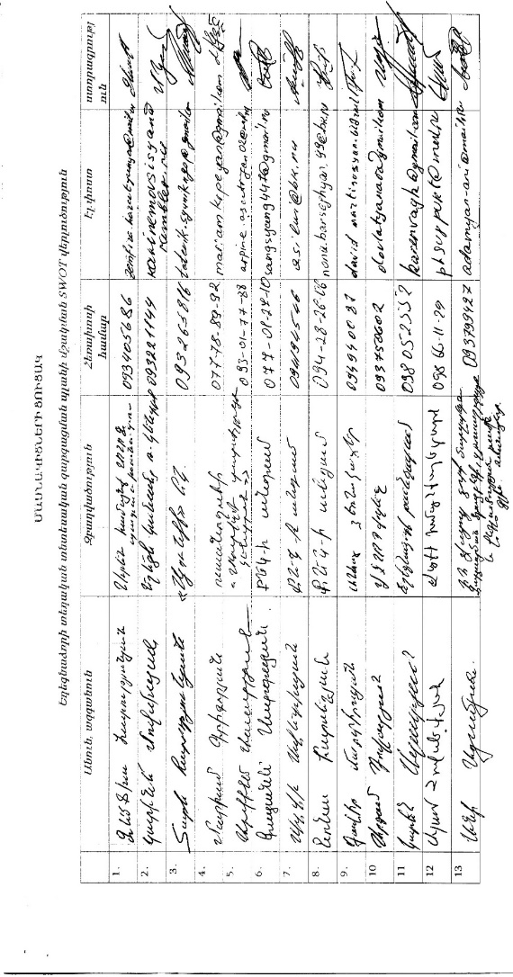

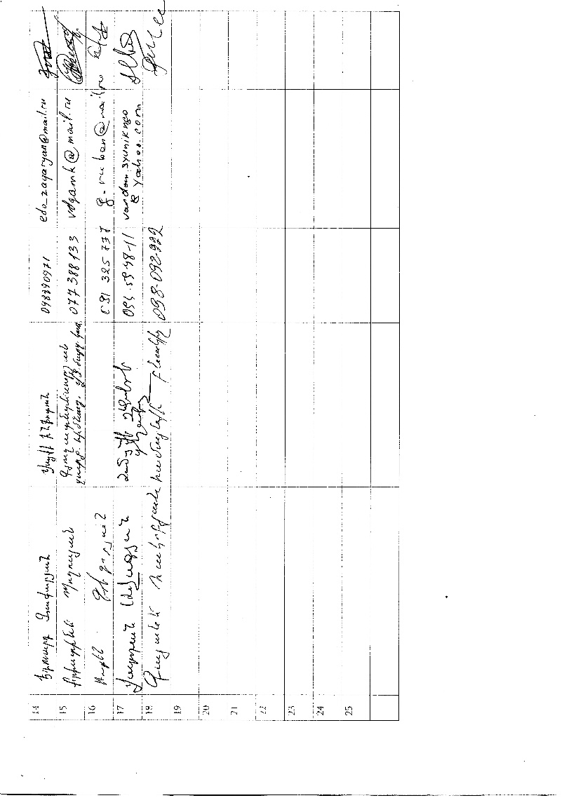

|  |  |  |  |
| --- | --- | --- | --- |
|  | **First name/last name** | **Organisation** | **Contact** |
| 1․ | Zemfira Harutyunyan | Local Economic Development Officer of Areni community | Zemfira.harutyunyan@mail.ru |
| 2․ | Karine Movsisyan | Director of Yeghegnadzor Women Resource centere NGO | karinemovsisyan@rambler.ru |
| 3․ | Tatev Harutyunyan | Member of Syunik NGO | tateviksyunikngo@yahoo.com |
| 4․ | Mariam Grigoryan | Student | mariamkrpeyan@gmail.com |
| 5․ | Arpine Asatryan | Member of Yeghegnadzor Tourism Center | Arpine.asatryan02@mail.ru |
| 6․ | Gayane Sargsyan | Member of Yeghegnadzor civil-youth center | Sargsyang.447@gmail.com |
| 7․ | Silvi Avetisyan | Member of Yeghegnadzor civil-youth center | 374 94414546 |
| 8․ | Nona Barseghyan | Member of Yeghegnadzor civil-youth center | Nona.barseghayn99@mail.ru |
| 9․ | David Martirosyan | Private Employer | davidmartirosyan@mail.ru |
| 10․ | Argam Dovlatyan | Director of Vayots dzor regional State College | dovlatyanar@gmail.com |
| 11․ | Karen Azatyan | Director of Yeghegnadzor Museum | karenvayk@gmail.com |
| 12․ | Aram Hovsepyan | Local Economic Development Officer of Vayk community | 374 98661129 |
| 13․ | Ani Adamyan | Responsible for projects of Vayots dzor region | Adamyan-ani@mail.ru |
| 14․ | Eduard Zakaryan | Vayk infotun | Edo_zakaryan@mail.ru |
| 15․ | Kristine Poghosyan | Fund of Vayots dzor Agriculture Development | vdgamk@mail.ru |
| 16․ | Ruben Grigoryan | Community resident | g.ruben@mail.ru |
| 17․ | Vardan Avagyan | Deputy mayor | Vardan.syunikngo@yahoo.com |
| 18․ | Gayane Hakobyan | Community resident | 374 98098222 |

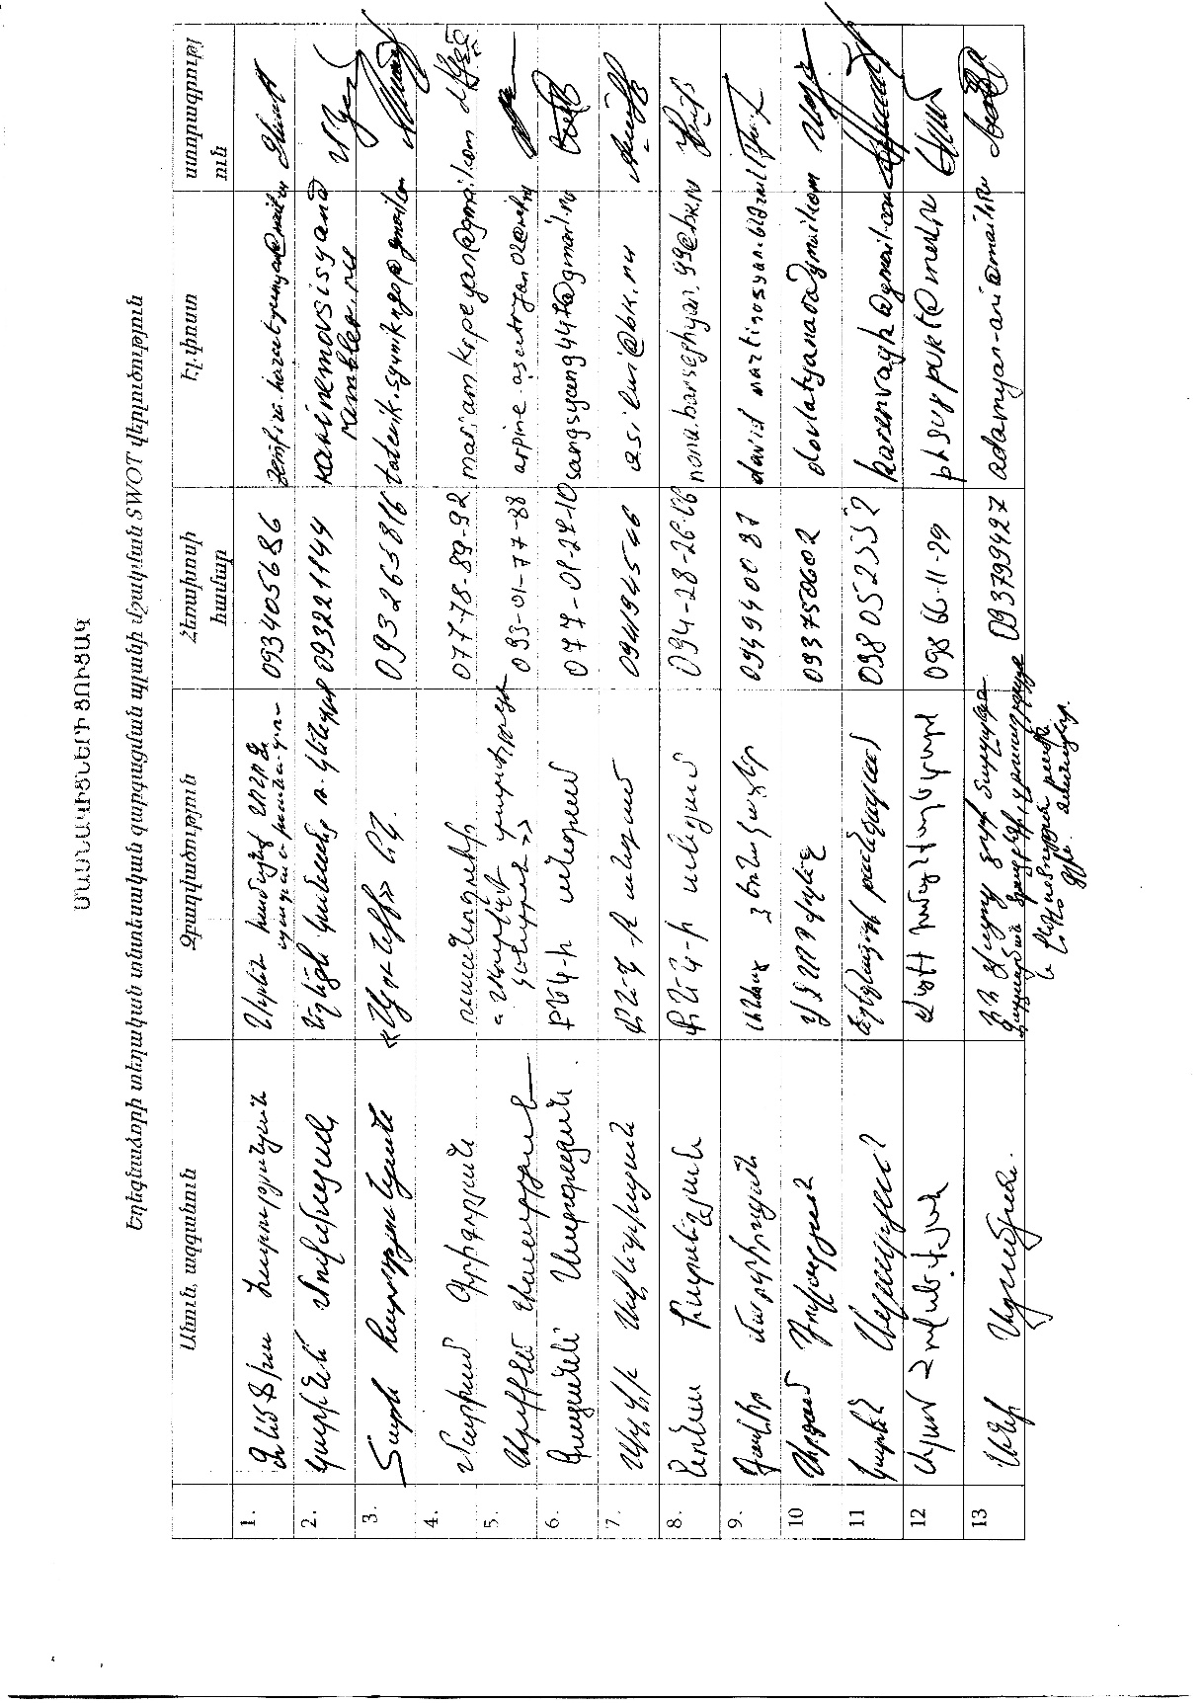

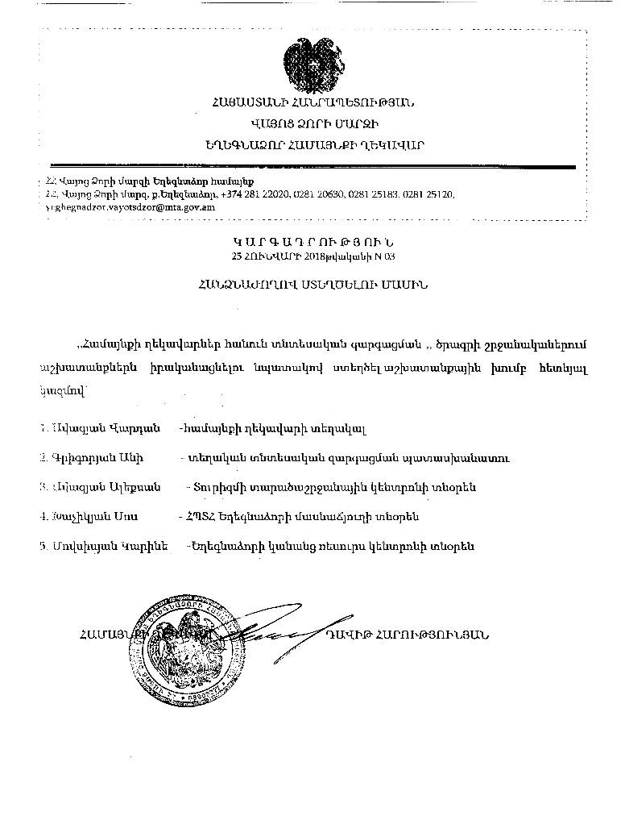

The partenship was formed under the initiative of Mayors for Economic Growth with the order No. 03 of January 25, 2018, with the participation of the community administration, the private sector and civil society representatives.

1. Vardan Avagyan- Deputy mayor
2. Ani Grigoryan – Local Economic Development officer
3. Aleksan Avagyan -The head of Vayots dzor **Tourism Regional Center**
4. Sos Khachikyan – Director in the Armenian State University of Economics Branch of Yeghegnadzor
5. Karine Movsisyan- Director of Yeghegnadzor Women's Resource Center